PowerPoint Basics – Pie Recipe

If you need to see what I mean by some of the instructions and what the slides will look like, scroll to the last page and you will see thumbnails of each slide (a.k.a. the Key)!

1. Create a new presentation using the Retrospect Design Theme and save it as *Pie* on your M:\ drive. Do not change the Variant color or font.

**PROOFREAD ALL TEXT**

1. On Slide #1, create a background by inserting a photo
   1. Right click on the slide, then Format Background, Picture or texture fill, File… and select *Apple Pie* from the S:\BOS\Strand 3*PPnt Data Files*\Pie Files folder or from Canvas
   2. Make the transparency 53%
2. Type **Homemade () Apple Pie** as the Title Text (press enter after Homemade so the text is on two lines)
   1. Select the text and change to Center align
   2. Apply a WordArt Style – Drawing Tools, Format, WordArt Styles down arrow, Fill-Orange, Accent 2, Outline – Accent 2 (the third style in the first row)
   3. Still on the Drawing Tools, Format ribbon, change the text fill to dark red and change the text outline color to green (both Standard colors)
   4. Change the text outline width to 3 pt.
   5. Apply the Chevron Up Transform text effect, (the first effect in the second Warp row)
   6. Type **Bake Sale – Saturday January 20** in the subtitle placeholder.
      1. Change the font of the subtitle to MV Boli and increase the font size to 30, bold and centered. Also change the font color to black
3. Create the following slides with layouts:
   1. Slides 2-4 with Two Content Layout
   2. Slide 5 with Content with Caption layout
   3. Slide 6 with the Picture with Caption layout
4. Add the following text on the slides:
   1. Slide #2
      1. Title: Choose the Right Apple
      2. Text in the left placeholder:

Jonathan

Honeycrisp

Granny Smith

Winesap

Braeburn

Rome Beauty

* 1. Slide #3
     1. Title: Ingredients
     2. Text in the right placeholder:

2 pie crusts for a 9-inch pie

¼ cup all-purpose flour

¾ cup granulated sugar

½ tsp. ground cinnamon

½ tsp. ground nutmeg

Dash of salt

2 tbs. butter

6 cups thinly sliced apples

* 1. Slide #4:
     1. Title: Directions
     2. Text in Left Placeholder:

Preheat oven to 425 degrees F.

Place crust in bottom of pie pan

Mix dry ingredients

Stir in apples

Place into pie crust

Dot with butter

Place second crust on top

Seal top crust to bottom

Slit top crust with knife

* 1. Slide #5:
     1. Title: Try a slice with whipped cream
  2. Slide #6:
     1. Title: Bake Two Pies (hit enter) Donate one to our bake sale – January 20

1. Insert the following pictures from the DATA FILES folder onto the following slides opposite the text (click on the Pictures icon in placeholder). Size the picture appropriately and move it to make it look good on the slide but not overpowering:
   1. Slide #2: Apples
   2. Slide #3: Ingredients
   3. Slide #4: Cooks
   4. Slide #5: Apple Pie Slice
   5. Slide #6: Bake Sale
      1. Click on the picture that is already there and delete it (Delete key on keyboard)
      2. Make the Bake Sale picture the background (see #2 above for help)
2. Save
3. Make the following changes to each slide:
   1. Slide #2:
      1. Title Text Size to 54 pt. and Font Color to Dark Red and Bold
      2. List font size to 24 pt.(you may need to make the placeholder larger to accommodate the new text size)
      3. Apply the Bevel Perspective Picture Style (Picture Tools, Format, Picture Styles down arrow) to the photo
      4. change the border to light green and the border weight to 6 pt.

Select the title text and use the Format Painter to apply the same formatting to the titles on Slide 3 and 4

* 1. Slide #3:
     1. List font size to 24 pt.
     2. Insert the pie shape (Insert, Illustrations, Shapes, Basic Shapes) to the lower left corner of the slide
        1. Make the size 1.8” high and 2” wide
        2. Apply the Shape Fill – Orange, Accent 1, Darker 25% to the shape
        3. Move the picture and shape as shown in the key below
        4. Add the text to the shape **Use Fresh Ingredients** (just click in it and type). Bold the text and change the font size to 18 if necessary
  2. Slide #4:
     1. List font size to 24 pt.
     2. Apply the Snip Diagonal Corner, White Picture Style to the photo
     3. Change the picture border color to Dark Red and then apply the reflection picture effect, Tight reflection, touching (1st one under Reflection Variations).
     4. Copy the pie shape from Slide #3 and paste it to the lower left of the picture. Replace the text with, **Bake 40 to 50 Minutes**
     5. Make the list into a numbered list (resize and/or move the placeholder so the text does not cover any of the pie shape or extend into the bottom graphic)
  3. Slide #5:
     1. Change the title text front to MV Boli, 40 pt. and Center align
     2. Apply the Simple Frame, White Picture style (1st one shown) to the photo and then change the border color to Orange, Accent 1
  4. Slide #6:
     1. Chang the title text font to MV Boli, 32 pt. and Bold

1. Apply the Peel Off transition in the Exciting Category and change the duration to 2.5 seconds. Apply to all slides.
2. Run Spell Check **and proofread**
3. Insert a Slide Footer (Insert, Text, Header & Footer, Slide)
   1. Fixed Date
   2. Student Name in Footer
   3. Don’t show on Title Slide
   4. Apply to All
4. 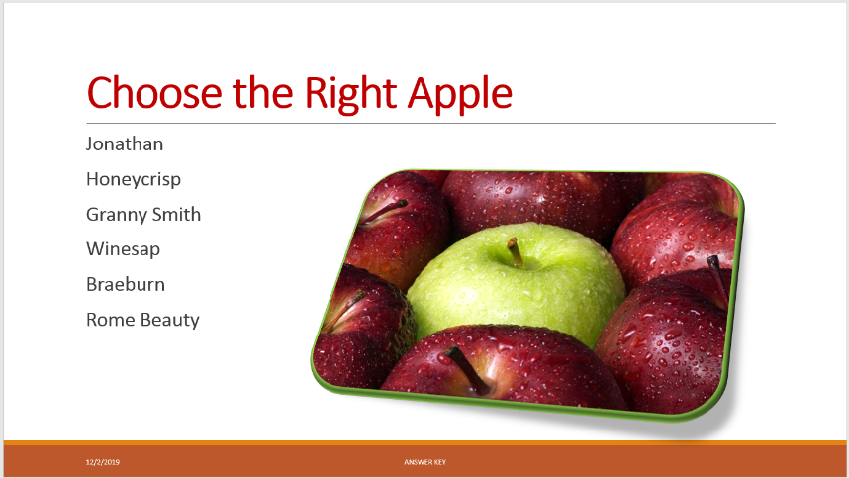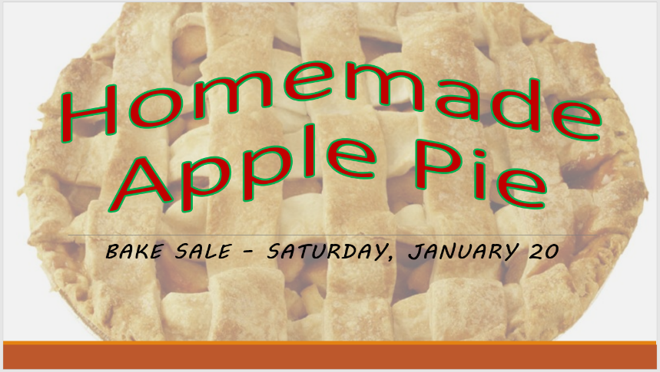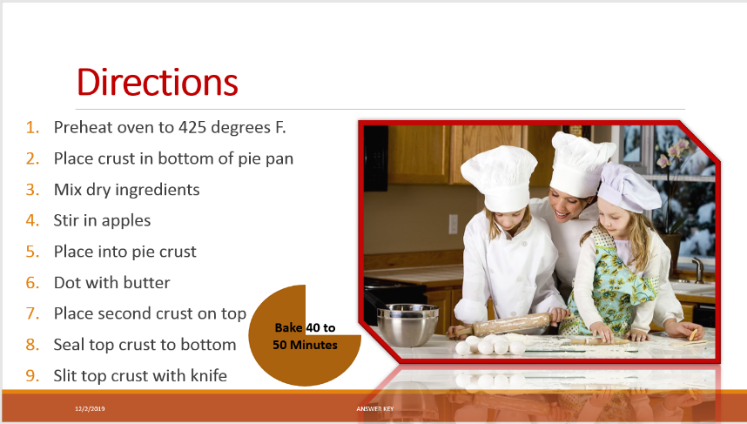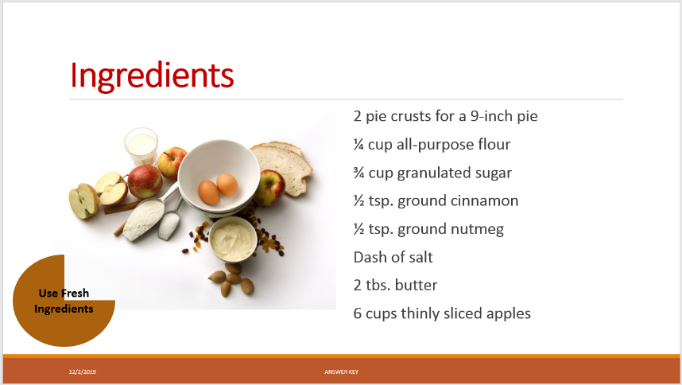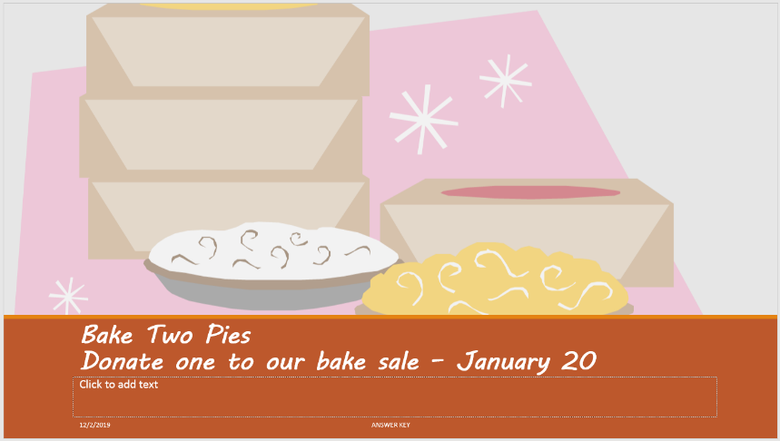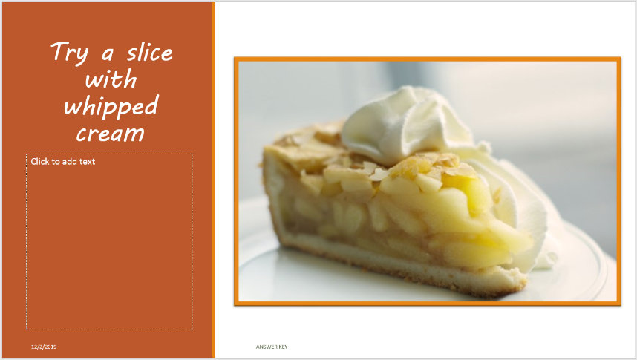Check with the key, make necessary changes and save